‘Frameworks’ Summary
- What is ‘Frameworks’?
- The ‘Frameworks’ Book, First Edition
- The ‘Frameworks’ Methodology
- The Ideas Around ‘Frameworks’
- The ‘Frameworks’ Tool (“The Intelligent Frame”)
- The ‘Frameworks’ Project, 1986-2026
- The ‘Frameworks’ Project Current
1. What is ‘Frameworks’?
‘Frameworks’ is the name I have given to a methodology for structured, independent, thinking and a simple computer-based tool for the construction of simple graphical images of thinking and understanding - that are simple graphical visualisations and interfaces to thinking that can be shared with others.
Keywords: methodology and tool (SIMPLE, entry-level*); structured and independent thinking; construction (constructivism and constructionism, Jean Piaget, Jerome Bruner and Seymour Papert); education and learning; understanding (comprehension); simple graphical visualisation; interfaces (thinking centred); representation, communication and sharing.
*Entry-level: “a good start” (providing for graduation to more sophisticated methodologies and tools).
‘Frameworks’ may be thought of as a paradigm for information modelling. With a visual theme, and the graphical modelling of schemata. It is a simple general-purpose methodology.
It is focused in the first instance on children (“the next generation of citizens of the world” as Daniel Levitin wrote in his book “The Organised Mind, Thinking Straight in the Age of Information Overload”).
And as I have argued in my book, for the education of early years children “who need to understand complexity as soon as possible”, who need to a learn capabilities and skills in “informatics” in the 21st century digital world, who will need to analyse and reduce complexity in global domains and systems to comprehensible and manageable proportions; who will need to deal with the chaos of the infosphere, and to make sense of it all and solve key existential problems.
I have argued and urged for understanding and engagement with the ideas and the practice of prototyping and Type C Projects.
‘I submit that ‘Frameworks’ has merit and potential.

‘Frameworks’ should be tested and evaluated NOW. Actions and the tangible louder than words and are capable of test and evaluation.
My thesis is concerned with human-centred computing and computing as should be exercised by “ordinary people”. My thesis is that the original vision of “personal computing” has become buried and overwhelmed by the ubiquitous technological development of smart IT with very smart algorithmically fashioned interfaces marketed by Big Tech. And now “AI”. The question is “Who is to be Master”?
‘Frameworks’ is for “ordinary people” who, with the benefit of the smart phone have been becoming gadget-led consumers. Browsing, streaming, chatting and entertainment. Creativity; creative thinking beyond the superficial, beyond the trivial, beyond the received, beyond the obvious, beyond the headlines? Leaving deeper and original creativity to the experts to the professionals? And becoming consumed by the current revolutionary development of “AI” artificial intelligence and the AI assistants/agents which at the touch of a button will automate so much – not only simple tasks but to relieve the individual of the task of creative thinking? In the construction of texts? In the processes of education – of teaching, of understanding, of learning?
While so much attention is being given to the development and application of “AI” across the board – including “AI in Education”, my thesis is that we should (re)consider the notion of “Human-Centred Computing” and the notions of augmentation (c.f. augmenting the human intellect ref AUGMENT, Douglas Engelbart) and symbiosis (ref Man-Computer Symbiosis, JCR Licklider). How about “AI and Education”?
‘Frameworks’ might occupy the territory between “AI” and HI” (human intelligence)?

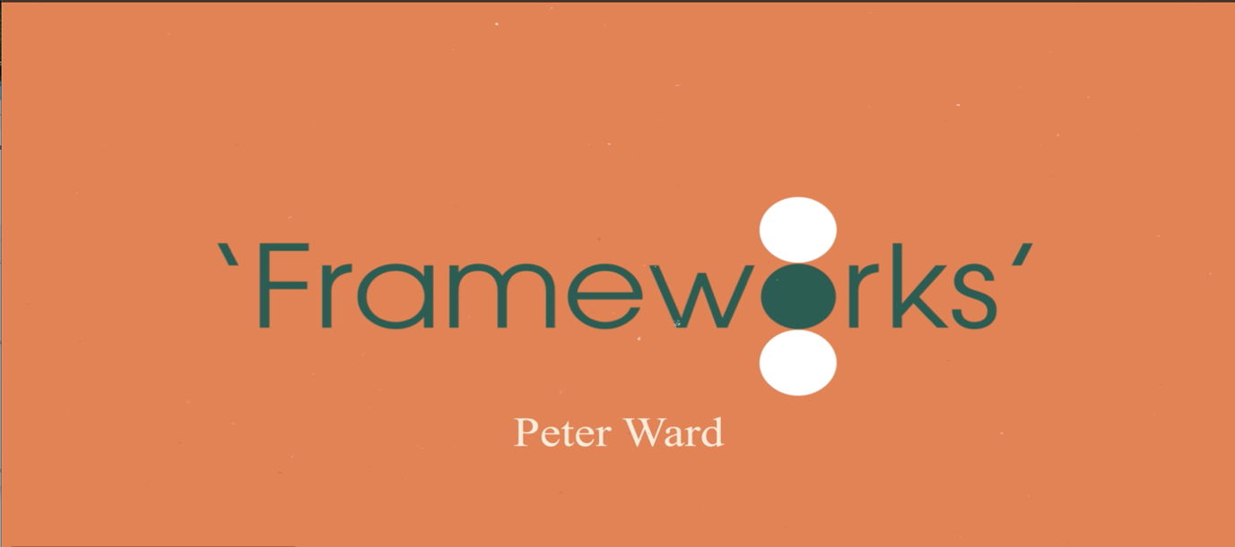
‘Frameworks’ addresses key simple questions: How do we (begin to) think? What are the simple steps in thinking about things? How might we communicate our thinking and understanding? How as adults (teachers, parents) might we discover (see) what children are thinking (about their world)? ‘Frameworks’ is about visual thinking and the visualisation of thinking.
As an educator I have been concerned and focused on facilitating learning and understanding, especially in those who appear to find it difficult to readily grasp things.
‘Frameworks’ is a methodology (and a tool) for Structured and Independent Thinking and for the construction of simple graphical models of thinking and understanding.
For children (the next generation of citizens of the world) and their teachers and their parents. In the face of complexity and information chaos - way of reducing scale and complexity to manageable proportions and a vehicle for sharing ideas and thinking.
For entry-level structured thinking and analysis and visual modelling for ‘ordinary people’. Setting aside the wealth of more sophisticated information modelling tools and methodologies that may be preferred by the tech-savvy and professionals.
The ‘Frameworks’ methodology has been greeted positively by a number of computer scientists, educationalists, designers and psychotherapists.



2. The Book ‘Frameworks’, First Edition Jan25
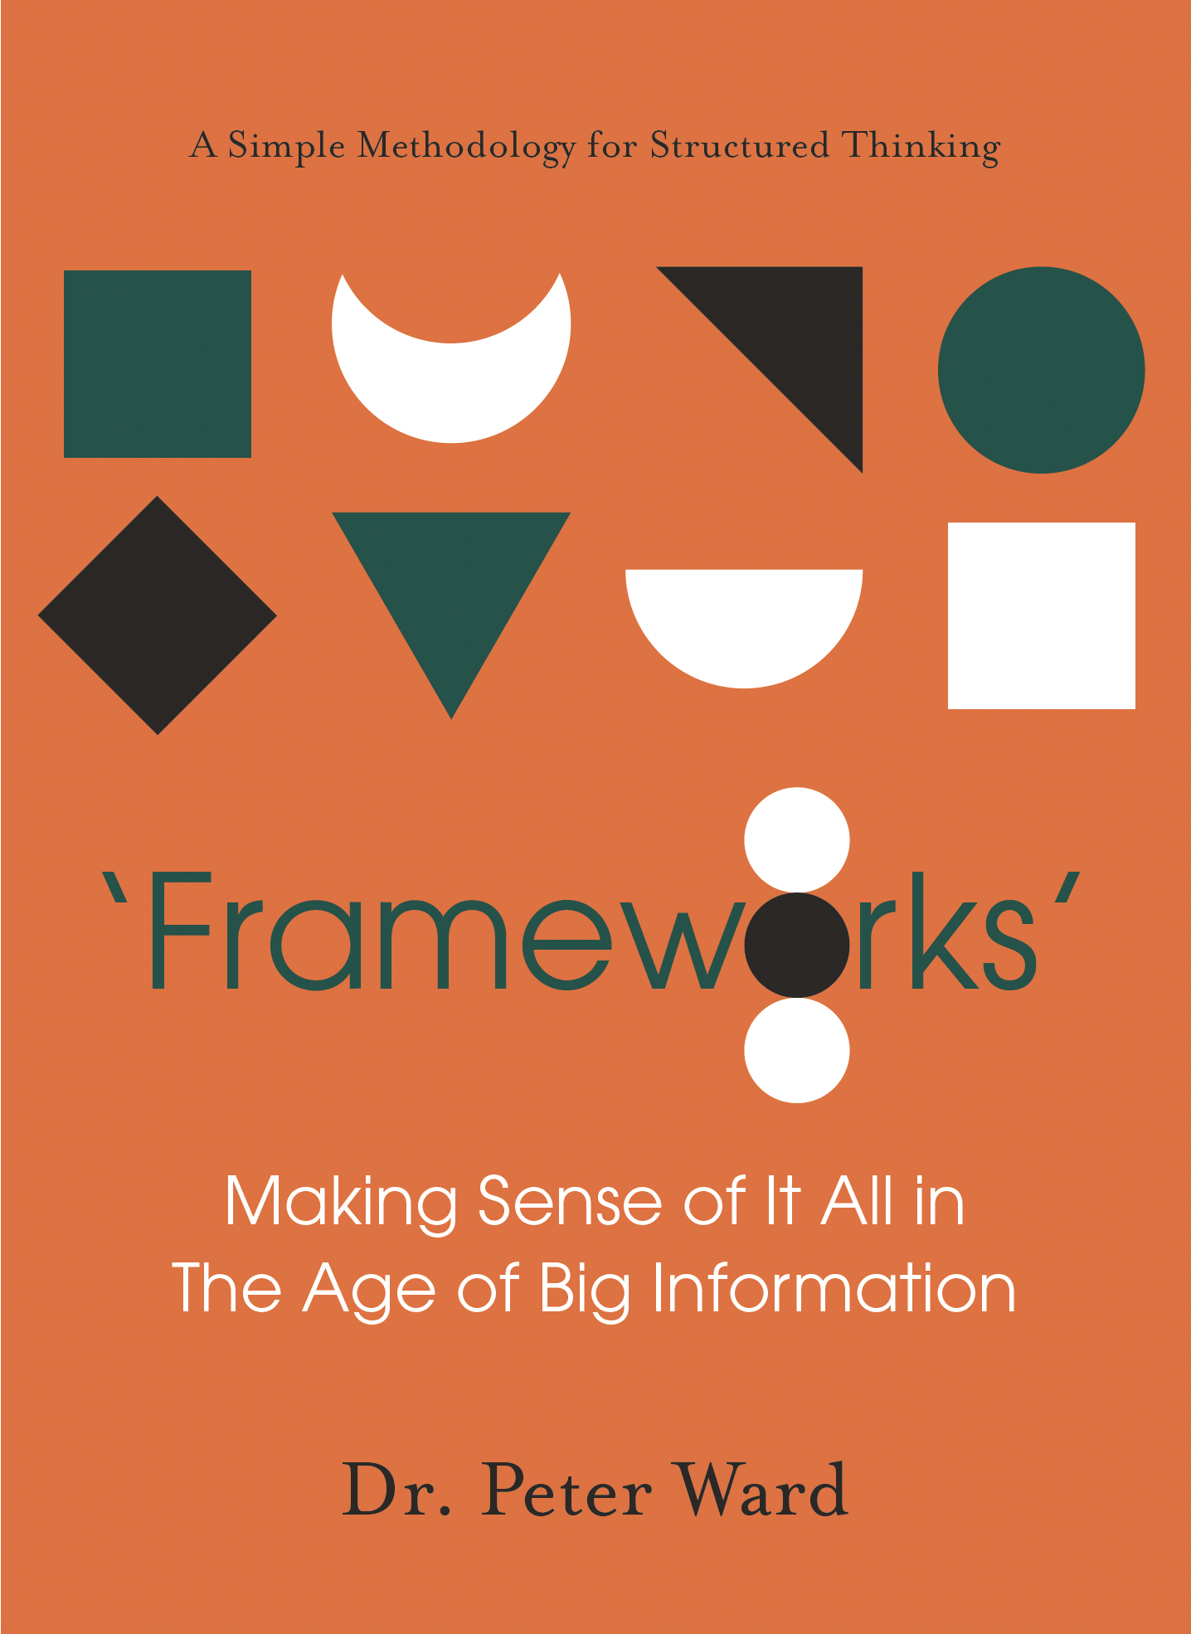
FOREWORD
Professor James Bown
Dean of the Faculty of Design, Informatics and Business,
Professor of Systems Biology
School of Design and Informatics
Abertay University

We live in an increasingly complex and highly interconnected world, that
interlinks seamlessly different real-world and virtual social structures,
locally and globally, through a mix of technologies and connected
economies. These interconnections offer significant benefits to our quality
of life, including increased social networks unfettered by distance; global
consumerism and trading; and high-quality, healthy and affordable food
and drink supply chains.
‘Frameworks’ offers a simple yet effective approach to modelling this
complexity. There are significant challenges posed by the interoperation of
these systems. For example, technology-mediated social interaction raises
concerns over privacy, safety and wider access; new business models must
be developed in the face of global competition and disruption to regulatory
systems; and food production must be appropriate and sustainable despite
an increasing population, decreasing natural resources and an increase
in food-related health concerns. These challenges, and many others, are
highly complex and progress towards solutions depends on clear, structured
and holistic thinking.

We are suffering an information overload. Never before has the rate of
production of information been so high. The information landscape is
so large that it is impossible to navigate without search engines, and the
information we find is in part determined by relevant content and in part
by the fit between relevant content and the underlying search engine
algorithm. As a result, the information we can reasonably access, which
is limited to the first few tens of sources drawn from a very, very large
number of sources, is at least partly normalised by the toolset that we
use. When one has expert knowledge of a subject domain, one can better
navigate that information landscape. Without that knowledge, it can be
difficult to differentiate fact from fiction and everything in between.
Next generation technologies powered by large language models have the
potential to synthesise that information landscape, but these technologies
can hallucinate and can also propagate flawed syntheses, thus distorting the
information landscape further.
‘Frameworks’ requires the thinker to include and exclude information
sets, and to determine hierarchies of entities, processes, and their
interconnections. ‘Frameworks’ encourages iteration and is sufficiently
simple that the approach can provide a bridge across discipline divides
without being distracted by methodological details. Perhaps most
importantly, ‘Frameworks’ is accessible and so a wide range of stakeholders,
including the next generation of future problem solvers, can contribute to
the systematic structuring of problem spaces.
‘Frameworks’ supports the systematic building of knowledge through
simplification, precise context definition and hierarchical abstraction.
In doing so, ‘Frameworks’ can mitigate – to an extent – that automated
landscape distortion by requiring one to actively model the information
explicitly.
As such, ‘Frameworks’ can complement existing search engines by helping
one think more simply through what it is one is searching for, and how the
(many) things that one might find interrelated.
In short, ‘Frameworks’ offers an elegantly simple approach to making sense
of the world in an era of rapid and disruptive change.
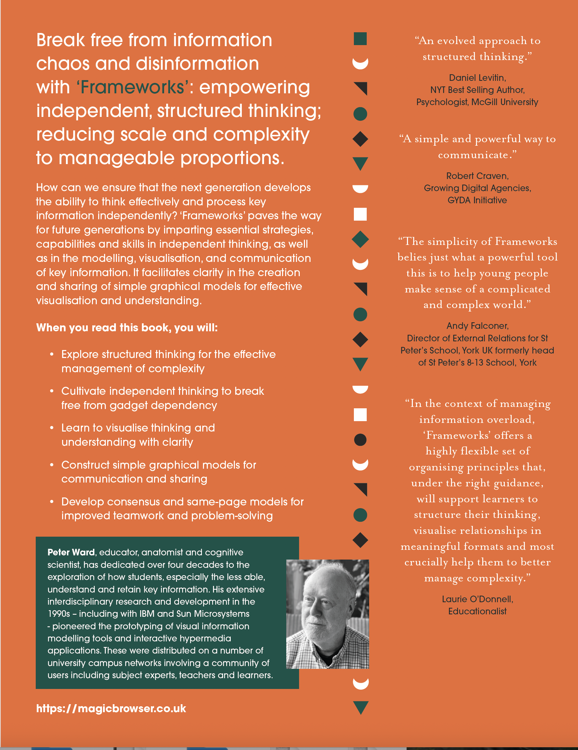

3. The ‘Frameworks’ Methodology
‘Frameworks’ is simple, visual, object-oriented, and minimal.
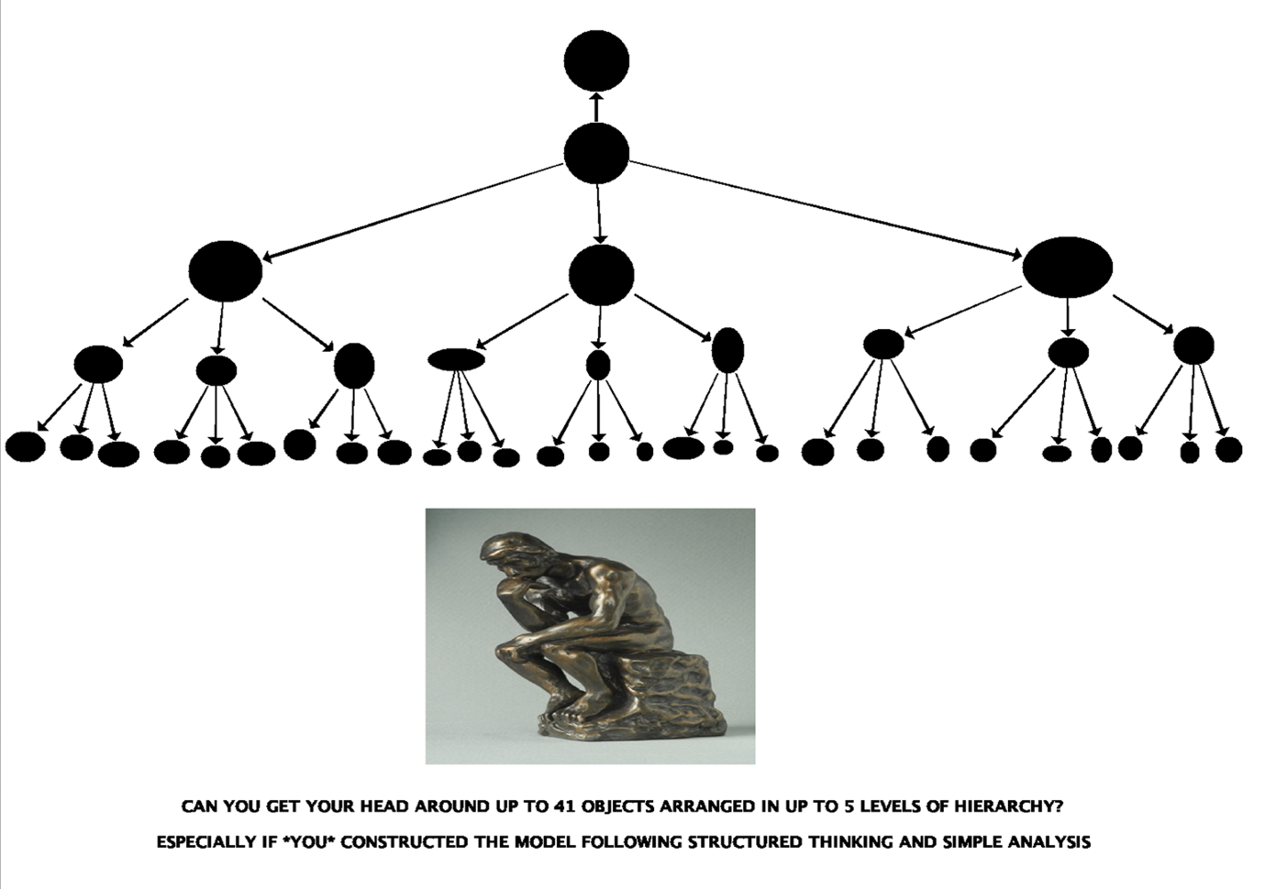
Evolved over some 40 years, The ‘Frameworks’ Methodology is a distillation of an evolutionary series of visual information modelling tools in the 1990s at the University of Leeds under the banner of the IMP Project (the information modelling programme).
https://magicbrowser.co.uk/
The ‘Frameworks’ design is represented in a simple Meta Model with a Core Spinal Model providing a simple hierchical core for the step-by-step elaboration of simple graphical models of thinking and understanding.
The ‘Frameworks’ Design: Meta Model, Core Spinal Model
The ‘Frameworks’ Meta Model is the representation of the key elements (Objects) of ‘Frameworks’; distilled down to a minimal model: a minimum number if Objects: Frame’; Thinking, Modelling, and Display Space; Core Spinal Model composed of Focus, Context and Instances; Stuff Box and Elaborate Button.
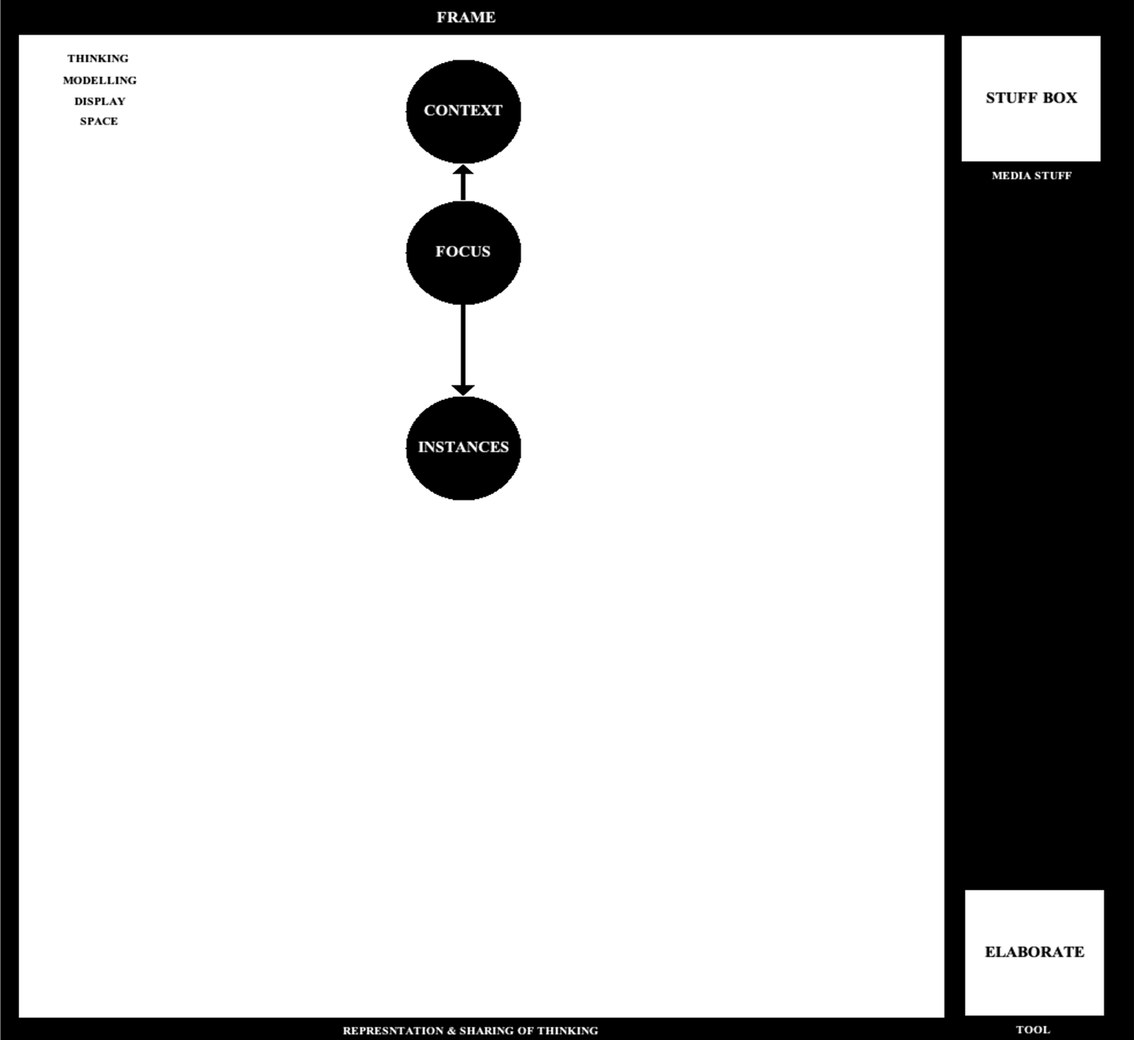
Thinking is modelled as a series of simple steps modelling simple cognition; from awareness, to sensation, discernment and recognition, to naming, clustering and categorisation, and then to arrangement/organisation into meaningful information structures/models.
Thinking and Modelling is “Framed”. The Core Spinal Model of Focus, Context (which is the determinant of meaning), and Instances. It provides a simple interactive experience following a simple sequence of thinking, focus, naming the Focus, realising and naming the Context, and the elaboration of a greater model representation the deconstruction and categorisation of Instances/Varieties of the Focus e.g. Penguins (and the Context of Climate Change) construction a Thinking Model of Climate Change and the role of Penguins. Elaboration is “Constrained” in a simple set of modelling levels: Novice, Intermediate and Advanced. The idea is that 999 Things is an almost impossibly large number to deal with; 99 Things proves an almost impossibly large number to deal with; and reducing the number to say 9 (or 21 or 42) is more manageable. And employing a process of clustering and categorisation – is an intelligent revealing and useful exercise in reducing scale and complexity to manageable proportions.
In the development of ‘Frameworks’, I constructed a whole series of “Thinking Models” in which I combined key words with graphical elements – intending these “Thinking Models” to be “parsed”, to be “browsed”, and words/elements of interest to be selected and as they are “hyperlinked” to definition and explanation, to learn something new. This is a screenshot of a computer-based “Thinking Model”.
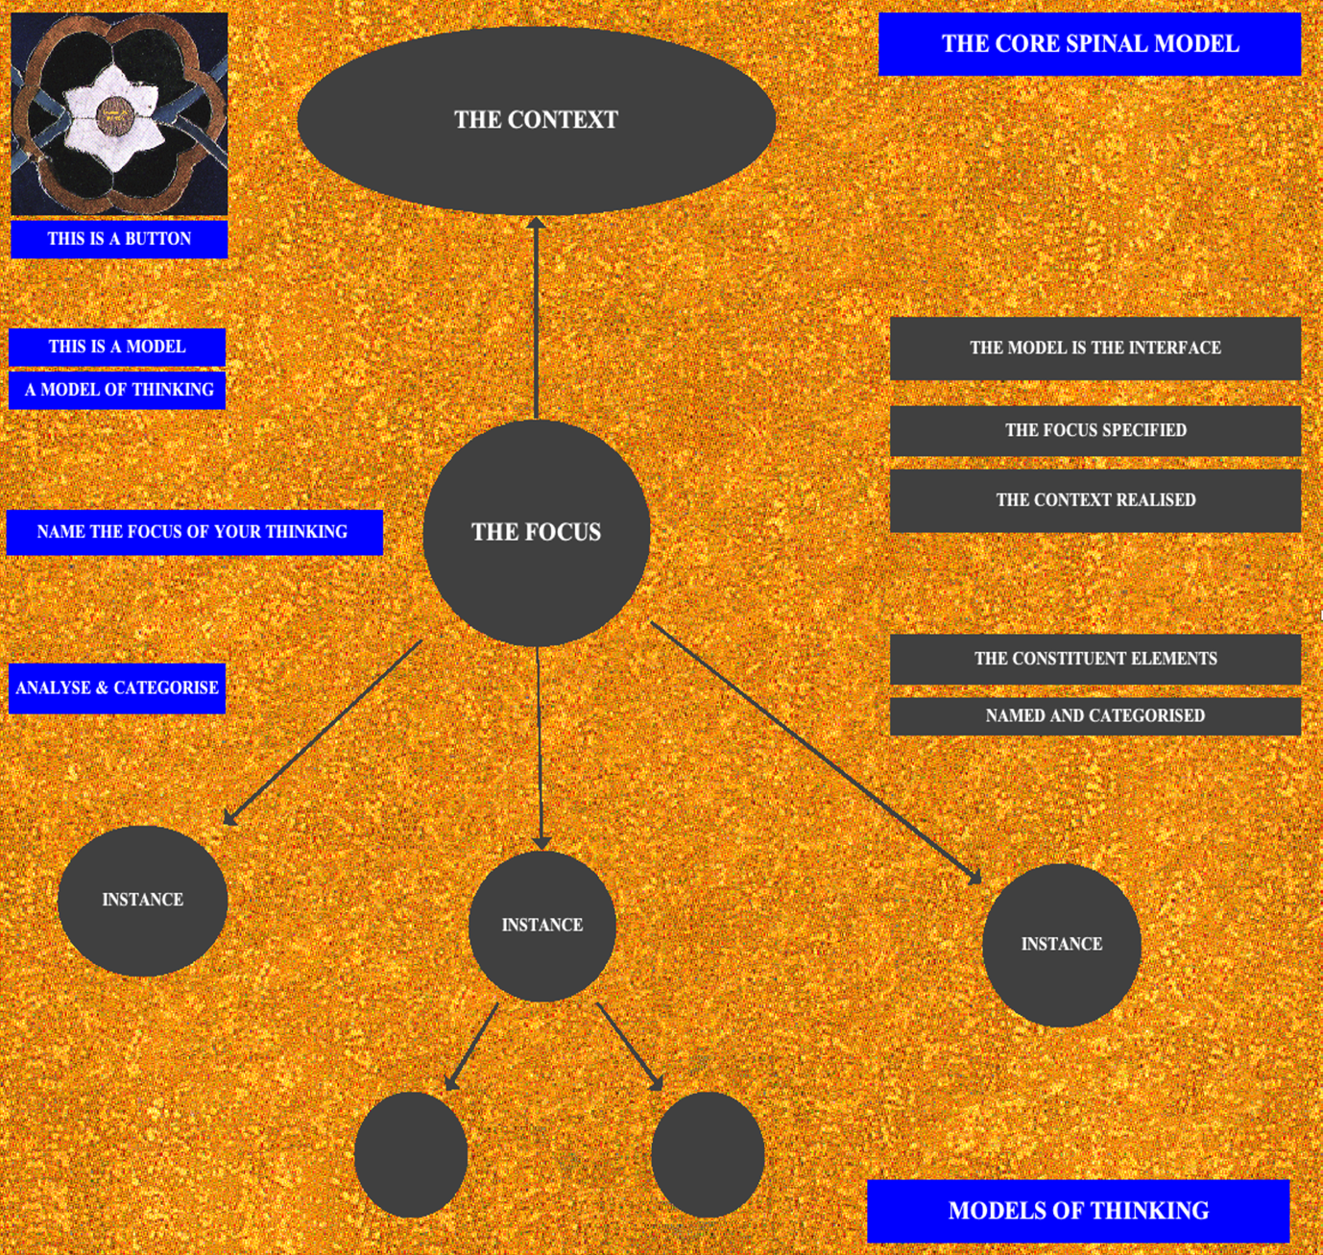
In this “Thinking Model” is included the ‘Frameworks’ Button; key ideas about the ‘Frameworks’ methodology; and the ‘Frameworks’ Core Spinal Model of Focus Context and Instances. Listed in the order: Focus First (to be named), then Context (to be realised and named), and Instances (constituent, varieties of the Focus Object) to be named and the Categorised.
The idea – the aim of ‘Frameworks’ modelling – is to reduce scale and complexity (LOTS) to managable proportions. To reduce cognitive overload by simple analysis, naming, clustering and the categorisation – a simple way of strucured thinking - according the simple representation and rule-based elaboration methodology of ‘Frameworks’.
Self-realisation? Structured, independent, creative thinking in the new age of AI?
‘Frameworks’ Represented in A Thinking Model in Context
‘Frameworks’ is an exercise in thinking about thinking: abstraction, object-oriented systems analysis and modelling, and visualisation.

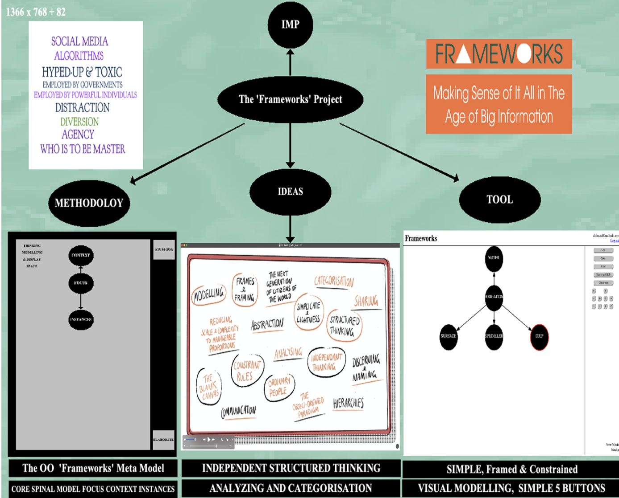

‘Frameworks’ on the Magic Browser Website
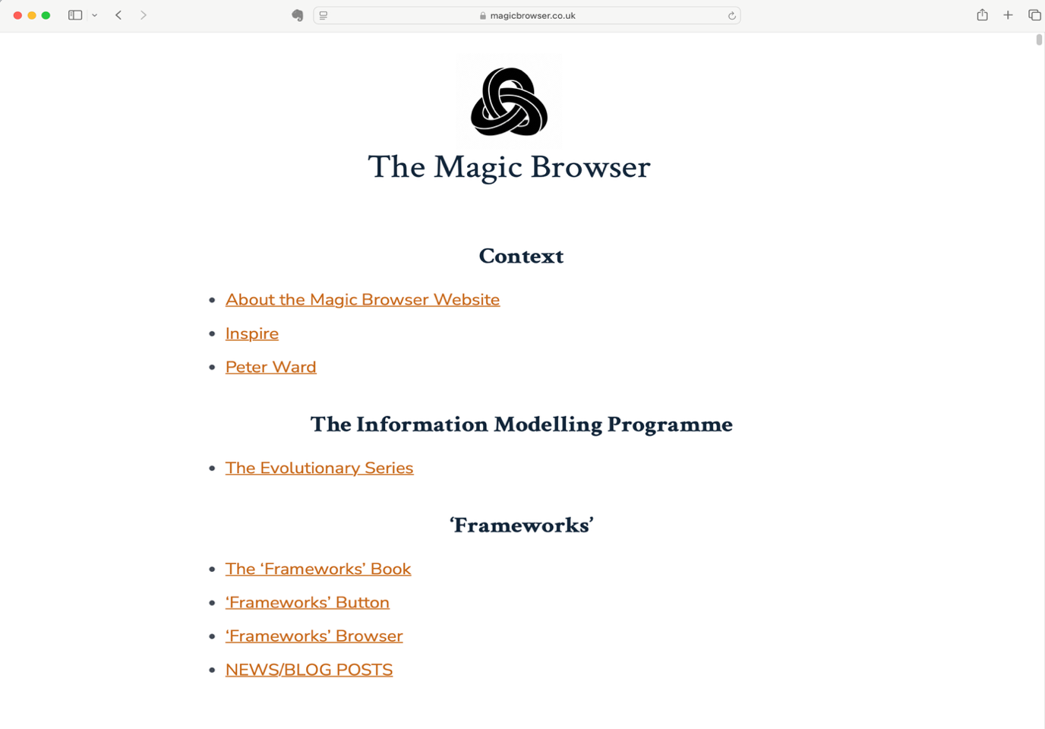
4. The Ideas Around ‘Frameworks’
There are a number of big ideas around ‘Frameworks’. Some of these have been briefly discussed in the ‘Frameworks’ Book First Edition; Brandspire Digital Limited, January 2025. An interdisciplinary exercise of cognitive science, computing science, education, psychology, the humanities, and philosophy.
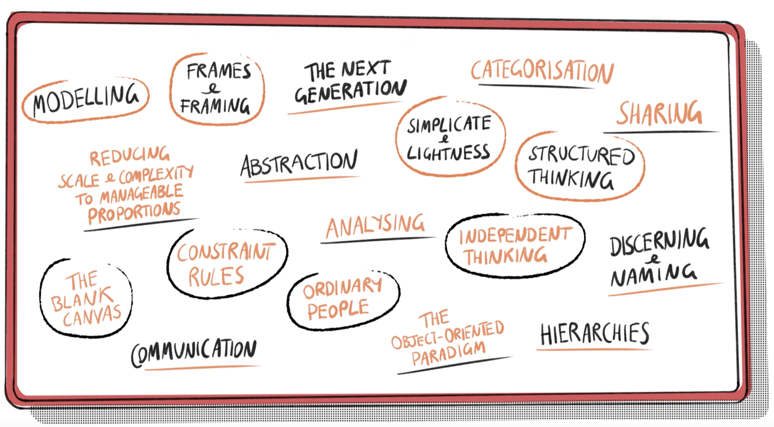
The world is a complex of evolving interrelated domains and systems. The digital world is complex and a chaos of LOTS of Stuff: data and information; seemingly controlled by Big Tech; including a plethora of disinformation, misinformation and bad actors; with interfaces designed to attract, engage, enthrall, distract and capture; creating a generation of gadget-led consumers. How to manage complexity? How to formulate structured and independent thinking? How to discover truth and make sense of it all? How to communicate thinking and meaning?
‘Frameworks’ is essentially Human-centred. Rather than “users” (in the technology domain, “allowed to” etc), ‘Frameworks’ designates “Thinker Modellers” (in the human cognitive domain, enabled to etc).
5. The ‘Frameworks’ Tool (“The Intelligent Frame”)
The ‘Frameworks’ tool has been evolved and prototyped and the current prototype (accessible on the Magic Browser Website) is Version 3.
The ‘Frameworks’ Tool is a realisation of the methodology: providing for “Thinker Modellers” to engage in a simple interactive experience: the construction of simple graphical models of their, individual and independent, thinking and understanding.
I have called the tool “The Intelligent Frame” because its elements - as “objects” (in the object-oriented design) - are configured with behaviour according to the methodology of OO modelling.
The idea is interactivity and discovery, enabled by the tool: providing a simple rules-based step-by-step construction of simple graphical models of thinking and understanding. To capture the “Thinker Modeller’s” Thinking and Understanding; to capture the chronology and the evolution of these Models, to analyse the data (interactivity and construction) and to analyse and to realise the (child’s) thinking and understanding.
In the evolution of “information modelling tools’ (see: https://magicbrowser.co.uk/the-evolutionary-series/), I have pursued a strategy of simple, minimal, interfaces with fewest buttons (focusing on interactivity, cognitive exploration and discovery) enabling access to the construction of simple graphical models: of systems and domains.
In PHASE ONE of the ‘Frameworks’ Project, Version 3 of the Tool was situated and accessible on the Magic Browser Website.
https://magicbrowser.co.uk/frameworks/
In ‘Frameworks’ modelling is framed and constrained (rule-based). Tere is a prescribed sequenceof model construction – first Focus to be Named, then Context to be realised and Named, and the simple rule-based Elaboration of a greater model. There are three levels of modelling: entry-level Novice (up to 41 Information Nodes in up to 5 Levels of Hierarchy), then Intermediate, then Advanced.
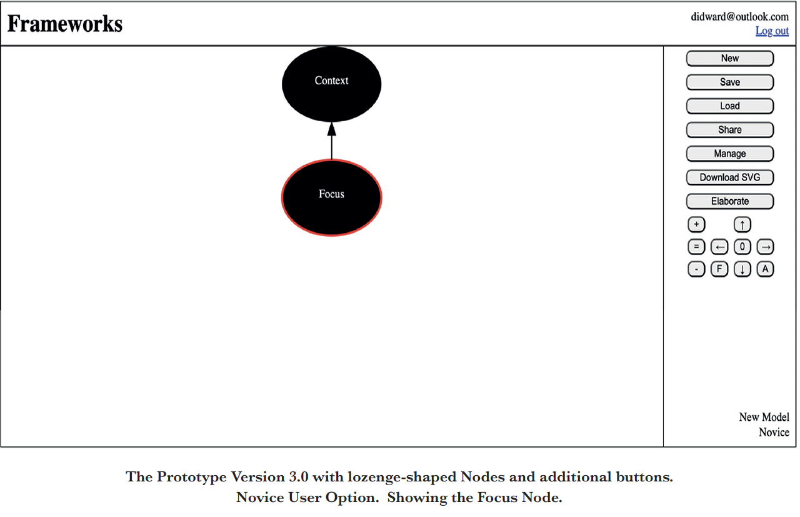
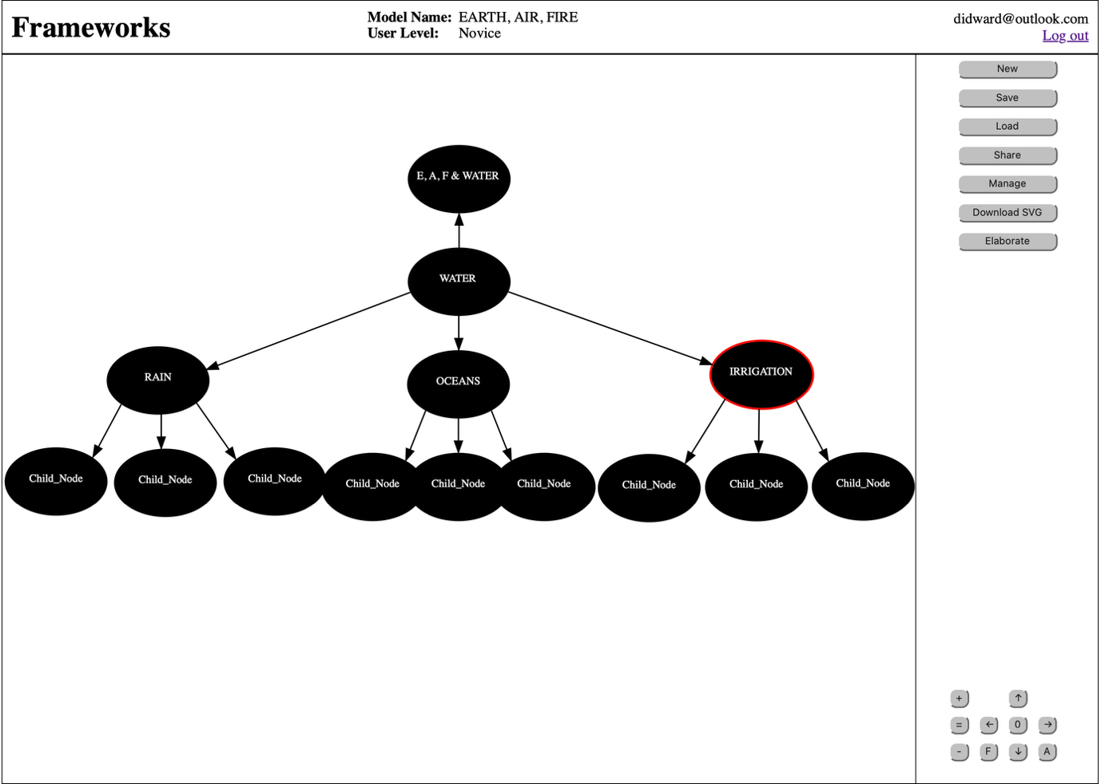

6. The ‘Frameworks’ Project 1986-2026
The ‘Frameworks’ Project really began in 1986 in the Department of Anatomy in the Leeds School of Medicine.
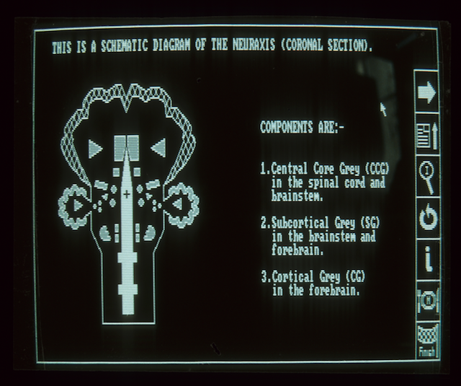
I had a vision of “computer-based information modelling” where large and complex systems (I started with the human nervous system) are represented as simple graphical schemata. Visual schemata, maps, visual summaries, visual overviews. “Information Models” constructed of individual elements. Containers; which organised into a meaningful model, a sort of map, could be browsed and interrogated: elements of interest selected and then hyperlinked to definition and detail. Interactivity being the key.
The educational challenge was/is Representing Systems and Domains to Students. More than lists. Cognition: Helping students understand large and complex systems. Devising a simple model of the system. Originally – the human nervous system, but of any system or domain. Reducing scale and complexity to manageable proportions. As simple and meaningful graphical models. With hyperlinking to stuff.

Organise and Construct models of understanding? Rote learning?
Some students appeared to find human anatomy and especially neuroanatomy difficult to grasp and resorted to rote-learning lists in order to pass examinations (examinations of what exactly?), while others combined rote-learning with (some form of?) “photographic memory”. Perhaps able to cognitively visualise the structures in 2-D or 3-D? My aim was to model e.g. graphically, schematically - and to visualise structure – for the situation of key information and for recall (remembering; cg Greek ‘Loci’).
The Vision
A vision of “computer-based information modelling”, of high-definition, high resolution colour displays. Modelling through simple analysis, naming and organising. The visualisation in models of systems/domains/thinking/understanding. Models which reduce scale and complexity to manageable proportions. Models which when displayed can be browsed with hyperlinks to stuff.
The ‘HNS’ Browser schematic displayed and interactive. Delivered on a state-of-the-art monochrome Compaq Portable computer with low-resolution display 480 x 240! Demonstrating computer-based browsable graphical schemata with hyperlinks.
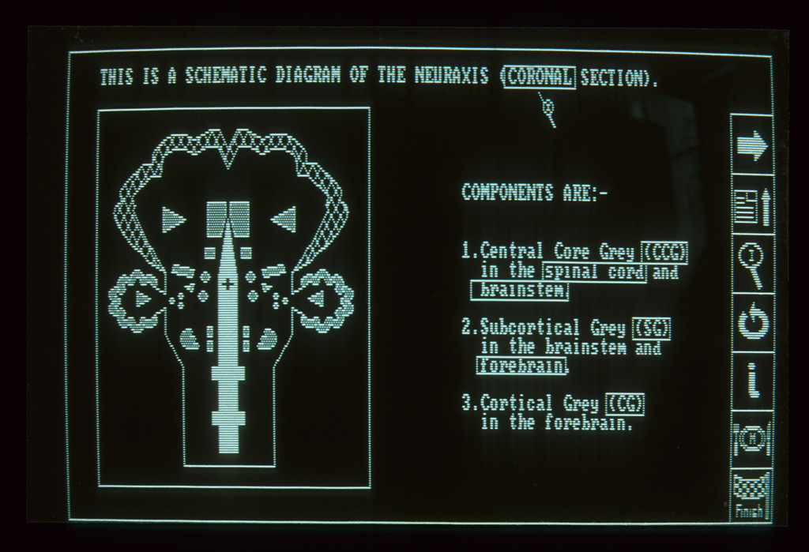

My vision in 1987 was of high-resolution colour graphical screens and active and interactive displays!
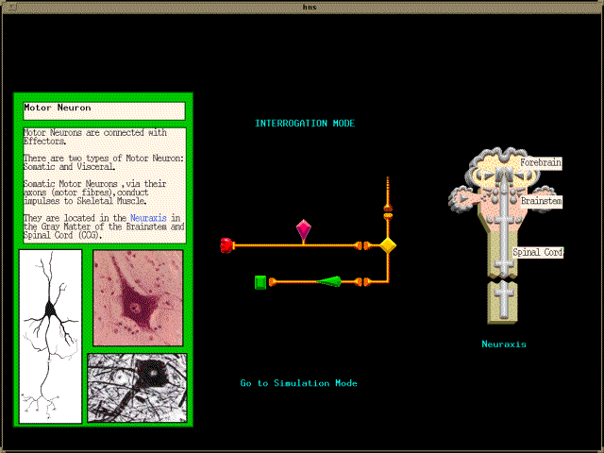
Think Simple Visual Graphical Interface
Think graphical user interfaces, think simple 5 button menus, think simple graphical images. Think visualisation. Think models of thinking and understanding as interfaces to thinking and understanding.
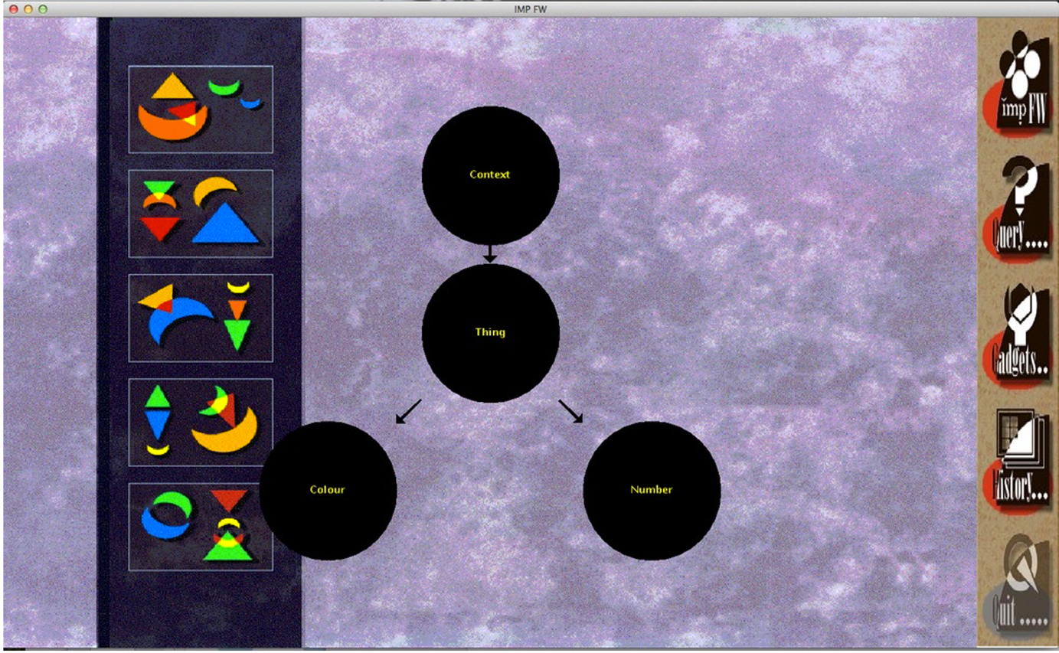
7. The ‘Frameworks’ Project today
Why? What for?
What Children Need
Children need to understand complexity as soon as possible. In their immediate cognitive development from early years to adolescence to higher learning.
Does a teenager or young adult need to understand complexity and ways of dealing with it (complexity)? Does a medical student, a student of economics, a student of engineering, a student of philosophy, a student of literature – need to understand complexity and ways of dealing with it?
Informatics in the 21st digital world
The next generation of citizens of the world. “Informatics’” (whatever that means) in an age of prodigious technological development and chaos!
“New Thinking” in Education and Education & AI. “New Thinking” can be cool, but beyond cool to a focus on the realisation of (new) thinking as tangible artefacts, tangible prototypes, as might contribute to education e.g. capabilities and skills in structured thinking and “analysing” in the 21st Century Infosphere?
‘Frameworks’ is about Thinking; structured thinking, and the representation and sharing of thinking. Think about the application of ‘Frameworks’ in Education. Children NEED to understand complexity as soon as possible. We must teach the next generation of citizens of the world to think clearly, completely, critically, and creatively. To think for themselves. In ‘Frameworks’, individuals are “Thinker Modellers” and are enabled to engage in the construction of simple graphical models of (their) thinking and understanding. Self-realisation? Structured, independent, creative thinking in the new age of AI?
‘Frameworks’ provides a simple way of structuring and sharing thinking. A world replete with state-of-the-art computer based tools and platforms. How is the current generation of Early Years children being introduced and educated about the 21st Century Infosphere?
‘Frameworks’ is simple methodology for reducing scale and complexity to manageable proportions, and provides a thinking tool enabling children – as independent individuals and in small groups – to construct simple graphical models of what they are thinking, what they understand. Teachers working with children working with parents – using ‘Frameworks’ to explore the idea of modelling thinking.
40 years later – the vision has evolved from the ‘HNS Browser’ to ‘Frameworks’. From a vision, a theory of information, a methodology for information modelling, and a simple tool for constructing simple graphical models of thinking.
The ‘Frameworks’ Project today is composed of two parts: two phases:
The ‘Frameworks’ Project is an example of “RAPID PROTOTYPING”] From Ideas, to the Theoretical, to the Design, to the Working Prototype.
PHASE ONE - Book; Website; Prototype Web-based Tool Version 3 delivered on the
Book (published January 2024, Brandspire Digital)
Methodology
Prototype Tool Version 3
[Magic Browser Website/’Frameworks’ Button/magicbrowser.co.uk/frameworks]
In PHASE ONE of the ‘Frameworks’ Project, Version 3 of the Tool was situated and accessible on the Magic Browser Website.
https://magicbrowser.co.uk/frameworks/

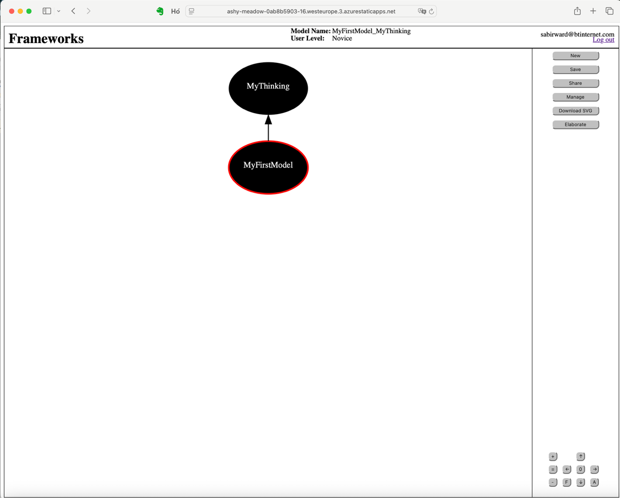

PHASE TWO - Uplift of Tool Version 3 to Version 4; Test & Evaluation in Testbeds with Teachers, Parents, Children; and also Psychotherapists and Designers.
‘Frameworks’ as an exercise (for children) in learning about complexity in the real world; and learning about strategies and skills for the chaotic and rapidly evolving digital world and for the vast 21st century infosphere including all sorts of bad and misleading stuff.
My OBJECTIVE in pursuit of the ‘Frameworks’ Project is to initiate PHASE TWO as soon as possible Summer 26 and to deliver Version 4 of the tool (web based) to be tested and evaluated by teachers their pupils and their parents.
The ‘Frameworks’ methodology and tool are a Prototype deserving of test and evaluation e.g. with 3 trainee teachers, 3 classroom teachers, and around 30 pupils.
The Uplift of the ‘Frameworks’ Tool Version 3 in PHASE TWO – is an Exemplar: of a Type C’ Project; small; speculative; short time frame; inexpensive 2/3 people] Douglas Engelbart and Alan Kay & Vishal Sikka
The Shared Model (Coloured Meta Model) {To be implemented in PHASE TWO}
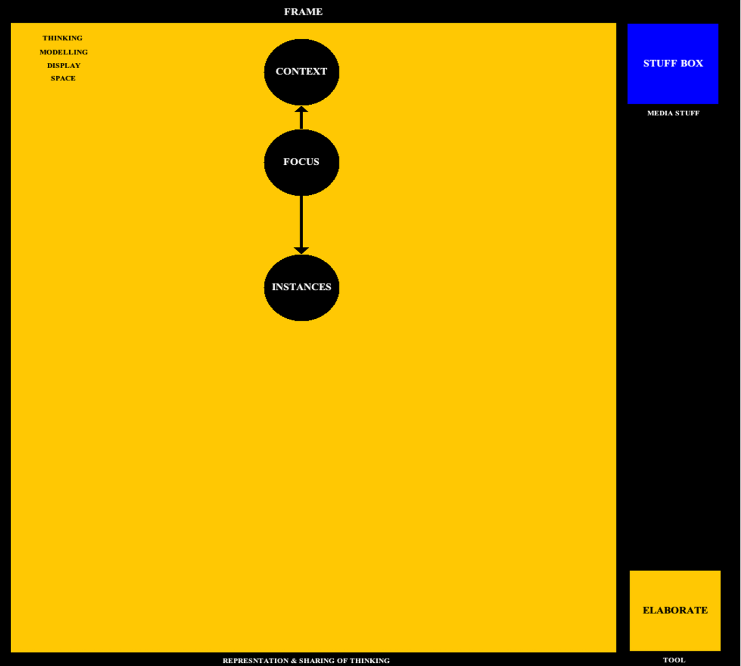
The idea is progression from the Meta Model, through the Elaboration of Thinking Models (with the Tool), to Sharing the ‘Frameworks’ Models with others (teachers, project team-mates). From the “black-and-white” to the world of static design and modelling tool, to the coloured world of communication.
(Refer: “The Wizard of Oz”, where the action begins in Kansas as Dorothy is caught up in the tornado and is transported to the Emerald City along the yellow brick road; the picture transforms from black-and-white to colour!)
The Thinker Modeller shares/ships/communicates their thinking and their modelling (displayed in the Display Space of the Meta Model) to a colleague who can adopt the Model (as freely available), populate the Model with Stuff (employing the Stuff Box) and/or Edit the Model in order to represent their thinking and understanding.
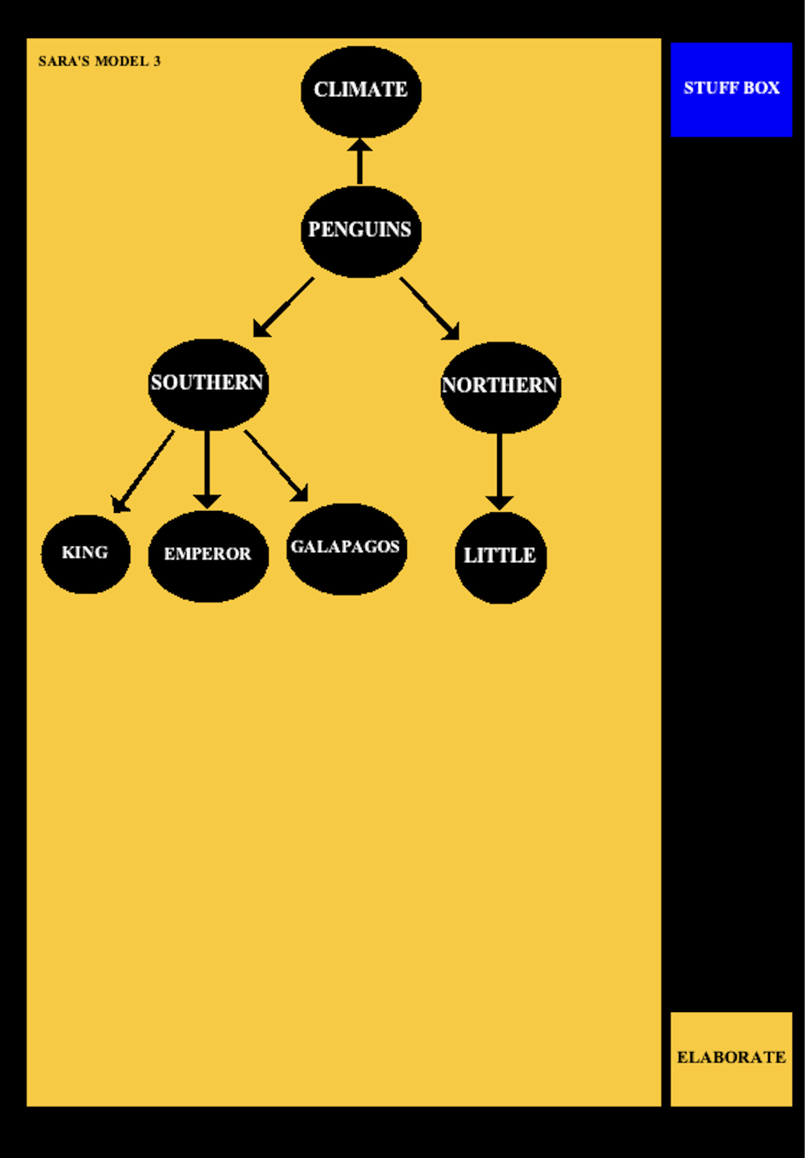
An example of the SHARED THINKING MODEL. The Coloured Meta Model is Shared with the Thinking Model displayed and the Stuff Box and Elaborate Button active and interactive!

PHASE TWO CURRENT PLAN SUMMER 2026
1. Uplift Tool Version 3 to Version 4 – [query JavaScript query ‘AI VIBE’ mechanism to generate code]
2. Version 3 BUG FIX
- TEST BEDS TEST & EVALUATE Tool Version 3; trainees teachers; schoolteachers, pupils, parents
- To fully implement SHARING
- “Coloured Meta Model” with SAVED MODEL displayed and BROWSABLE with hyperlinks to Stuff
- Coloured Meta Model with STUFF BOX and ELABORATE BUTTON
- To implement the STUFF BOX with Sandbox (first port of call for Stuff)
- To implement the ELABORATE BUTTON with link to Tool which will then display the Shared/Archived Model. Which Model may now be edited etc and saved as new alternative variant Model. And archived and shared. In a cycle.
Thus – the Models shared in the form of a Coloured Meta Model include access to the ‘Frameworks’ tool via the Elaborate Button.

The STUFF Box
In ‘Frameworks’ – data, information, files and everything in the digital world is called ‘Stuff”.
The Thinker-Modeller constructs a model(s) of their thinking/understanding around the ‘Frameworks’ Core Spinal Model – starting with Naming their Focus, then Naming their Context, and then in Elaboration of this default model they may deconstruct and detail the various elements of their Focus. This deconstruction and categorisation is framed and rule-based – from Novice modelling through Intermediate and Advanced Modelling.
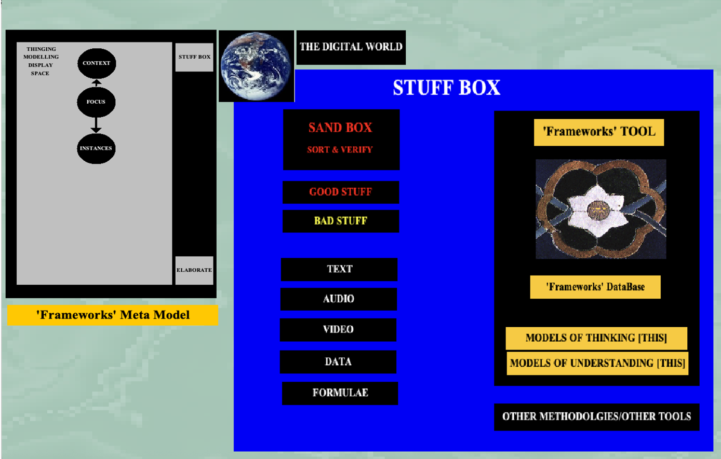
The Design of ‘Frameworks’ is based on the simple object-oriented Meta Model (consisting of 5 objects: Frame; Thinking/Modelling/Display Space; Core Spinal Model [Focus, Context and Instances]; Stuff Box; and Elaborate Button).
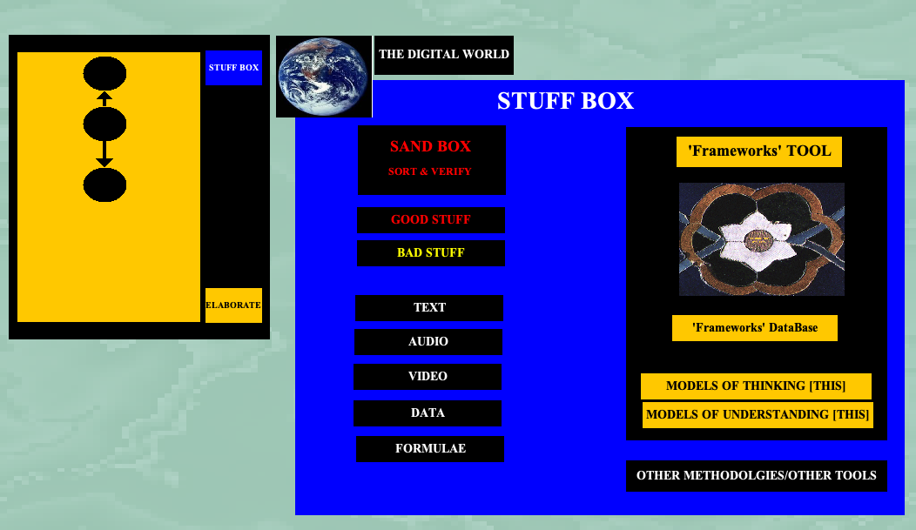
This Design/Thinking Model – depicts the Coloured Meta Model as exported/saved in the Model. After Elaboration of an individual Thinking Model - the Coloured Meta Model the Stuff Box may be Shared and “Stuff” (files, information, data) located (on the internet, in the Cloud) is copied into the Stuff Box (of the Model)
Thus, the Stuff Box is a Container for Stuff – which is associated with the Focus and the Context of the Model. The Stuff Box includes containers (folders) for (various) Stuff AND the first port of call is the SAND BOX. Where Stuff can be sorted and verified, and the Good Stuff can be copied into various media/type files for association/linking to the Information Nodes of the Model (the default model Focus Node and Context Node//and in a greater model Instances Nodes).
As a Container for Stuff, the Stuff Box may be configured to contain an unsorted/sorted database of stuff/files and a database of all (variant) models of the Focus and/or the Context. It may also contain other methodologies/other tools for modelling e.g. ‘Mind Map; Loomio; Concept Maps etc.

KEY INPUTS REQUIRED
I am an individual (with a track record of realising vision, original ideas and theory into tangible realities (a series of software prototypes dating back to 1987) into seeking engagement (academic institution of business) and support (intellectual, advice and academic inputs; financial*)
0. Technical Support - Tech Savvy - Assistant Website (WordPress) Social Media Substack Post with 3 x Video Animations plus ‘Tool showing process of Construction Screen Capture’

00. Technical Support (Tech Savvy) AZUR PLATFORM SECURED (12 months, 3 teachers trainees; 3 teachers school 60 pupils; 30 parents)(100 users)(3 models each)(300 Models Database)

000. DISSEMINATION (seminar/academic paper?podcast; TED talk)
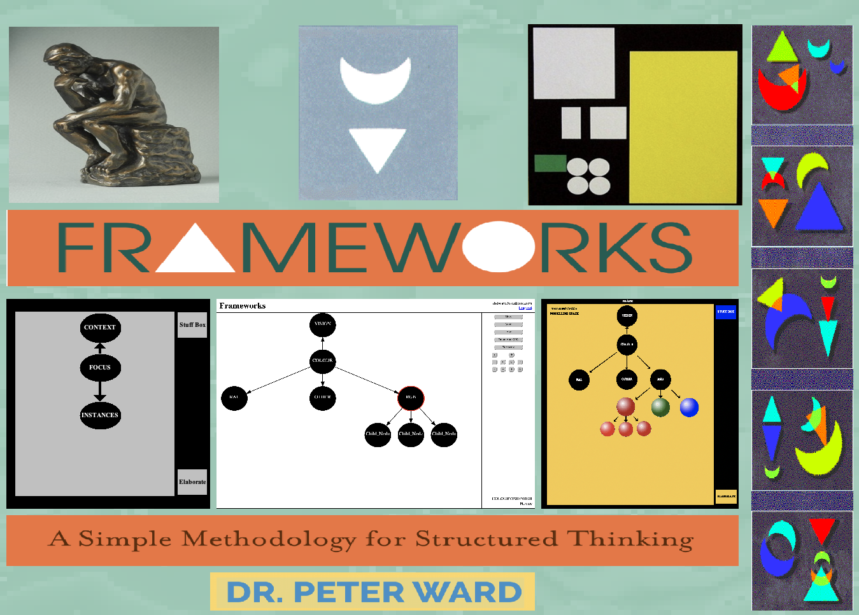
SEE Video Animations
https://magicbrowser.co.uk/frameworks-browser/
END ‘Frameworks’ SUMMARY DOCUMENT

